# PSS PCS-RASP

## To setup Raspberry OS configuration

1. To enable i2c on raspberry
   1. sudo raspi-config
   2. select 5 Interfacing Options
   3. select P5 I2C
2. To see all connected devices
   1. sudo i2cdetect -y 1

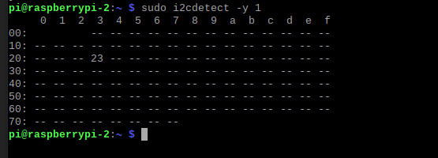

## To pull pcs-rasp project from Github

1. Turn off git ssl to enable git clone
   1. git config --global http.sslverify false
2. git clone <https://github.com/PSS-GROOT/pcs-rasp>
3. To create virtual environment and install requirement , at your pcs-rasp directory after clone
   1. pip3 install virtualenv
   2. python3 -m virtualenv venv
   3. pip install -r requirments.txt

## To set auto boot up / startup with crontab

1. cp /home/pi/raspStart.sh /home/pi/pcs-rasp/raspStart.sh
2. Grant permission for the shell file
   1. sudo chmod 775 /home/pi/raspStart.sh
3. To setup crontab with the raspStart.sh
   1. sudo crontab –e
   2. choose any editor if you'r first time
   3. @reboot /home/pi/raspStart.sh > /var/log/rasp/client.log 2>&1
4. To check running cron status
   1. ps -ef | grep crond
   2. systemctl status cron

Set to Crontab – Running in background

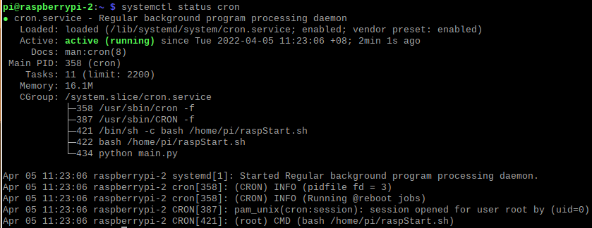

1. pm2 startup
   1. <https://pm2.keymetrics.io/docs/usage/startup/>

## To start python script

1. Stop cron job
   1. Sudo systemctl stop cron
2. Run the raspStart.sh , I put at root directory
   1. Inside raspStart.sh -> cd /home/pi/pcs-rasp/ && source venv/bin/activate && python main.py



## To manage log file when size keep growing

1. Current Hard Disk Capacity

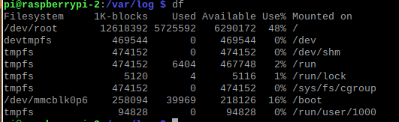

1. To manage log auto rotate
   1. sudo apt update && apt install logrotate
   2. To add specific directory for logrotate
      1. Sudo nano /etc/logrotate.d/apache2.conf

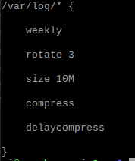

* 1. To trigger log rotate
     1. logrotate -d /etc/logrotate.d/apache2.conf
  2. To view log file
     1. less +F /var/log/client.py

## Reference

## https://bc-robotics.com/tutorials/setting-cron-job-raspberry-pi/

## https://www.tecmint.com/install-logrotate-to-manage-log-rotation-in-linux/